**Out of Time:**

**A Temporal Odyssey**

By Enes Etem

**Table of Contents**

**Game Summary 4**

Game title 4

Story Summary 4

USP’s 4

**Market Analysis and Research 4**

Competitor Analysis 4

Target Audience 5

Market Research 6

**Goals 7**

User Experience 7

Internal Goals 7

External Goals 8

Gameplay Goals 8

**Gameplay 9**

Game engine and system 9

Game dynamics 9

Player controls 9

Gameplay loop 9

**Level Design 10**

Backstory/Narrative Design 10

Flowcharts 13

Annotated Map 15

World Building 16

Beat chart 18

Feedback Loops 19

**Art Style and Aesthetics 20**

Environment 20

Theme and Mood 21

Form 21

Style 21

Setting 21

Colors / Lightning 21

**Future development and peer feedback 22**

Playtesting 23

Game walkthrough 23

One pager 24

**Sources 25**

Assets 25

Images 26

References 26

**Game Summary**

**Game title**

I have chosen this title because it reflects the concept of the game and is directly linked to it. The player is running **out of time** on a long, exciting journey (**odyssey**) where they try to find the true purpose of time.

**Story Summary**

You are a clan leader/warrior who was fighting a great battle alongside your clan. As your enemies closed in for the final strike, a mystic energy being took you away to an unfamiliar realm. However, your clan still needs you, but you need to prove that you are worthy to go back. To do so, you overcome obstacles, collect hidden artifacts, fight enemies, and make your way to the end stone.

**USP’S**

The unique selling points of the game are the relaxing visual aesthetics that immerse the player into this new world, character animations that make the game feel dynamic, mechanics, puzzles, interactions, and characters with their own personalities, where the player has complete freedom to explore and learn the mysterious story and secrets.

* Time can be collected, as “Time orbs”.
* Explore and find the multiple endings.
* Detailed story and level design

**Market Analysis and Research**

**Competitor Analysis**

After doing an analysis of other competitor games I came up with the following: Braid, Inside, Limbo, The Swapper, Fez, Oxen free, Rayman, Super Mario Bros, Sonic the Hedgehog, and Cave Story. The main aspects that these games have in common are puzzle solving, exploration and narrative depth. Additionally, they all have a unique mechanic or aesthetic, such as 2.5D gameplay or dark themes.

**Target Audience**

The target audience of the game are the people who enjoy 2D Platformer adventure games, fans of indie games that offer unique experiences, puzzle-solving and narrative depth. Those who are fond of exploration and open world games, with great storylines and mechanics. To come up with a persona, I tried to find demographics of the players. From what I have found, most of the people are males (87.5%) in the age range of less than 18(55%), and 23-27(20%) (Clack, 2023). Taking this into account, I consider that the 23-27 age is more appropriate for my game. After considering all these criteria’s I have created a persona using Miro (Miro, 2023)

**Market Research**

The game that I have made can be classified as a platformer, in which the main objective is to get the player from point A to point B.

While many gamers don't notice, platforming games are the most important aspect of gaming. Due to its importance, fans will never let it go out of style. It has been proven repeatedly with franchises like Super Mario Bros. that there is a versatility to the property that keeps fans coming back with every update. Platforming has come a long way and has helped bring in some of the most iconic names in gaming. Its importance stems from the understanding that almost all games need platforming, whether it's their biggest draw or not. Over its history, developers have innovated the simple mechanic to keep up with the times and justify its importance. Platforming will never go out of style because gaming will always need it. (Brooks, 2021)

In the evolving landscape of video games industry, the platformer genre continues to grow, due to the easier accesibility of gaming platforms. The dominance of traditional gaming consoles, including PlayStation, Xbox, and Nintendo Switch, remains essential in the platformer market.

Within this competitive landscape, established franchises like "Super Mario," "Sonic the Hedgehog," and "Rayman" continue to have a significant influence, highlighting the genre's enduring appeal. Success in the platformer market often relies on a delicate balance between accessibility for casual gamers and challenges for the hardcore audience. The most successful platformer games integrate innovative gameplay mechanics, distinctive art styles, and captivating narratives, creating a an engaging player experience. Moreover, games that combine different genres, incorporating elements of puzzles, exploration, or roguelike mechanics, are quite appreciated among players seeking novel and varied gaming experiences.

In conclusion, the platformer game that I have made fits the specific market and target audience, by having its own narrative, level design and difficulty. Even though there are more well-known games, having my concept on a platform such as PC can be a good start.

**Goals**

**User Experience**

The player has the freedom of exploring from the moment they press play, giving them an early **sense of** **engagement and immersion.**

The player is gradually introduced to game mechanics, starting with a decreased difficulty level, that slowly increases, giving them the power of **learning and mastery**.

The player can explore every part of the level, and they can always go back to previous levels, making it an **open world game with a semi-linear structure**.

The player can interact with different elements such as chests or NPC’s, that act the same in the following levels as well, which **follows the environmental rules**.

Interacting with NPC’s does not take away the freedom of moving, making it optional, however they are the ones giving details of the story and **integrating the narrative**.

**Internal Goals**

Internal goals are useful, as they give a clear direction and focus for the designer, helping them understand the intended player experience and the core objectives of the game:

Players should feel relaxed and calm while admiring the visual aesthetics.

Players should feel an emotional balance of pressure and relaxation as they explore the environment and keep track of their remaining time .

Players should be in flow state when progressing to the obstacles and parkour required to progress through the level.

The player should feel ambitious and determined to finish the level, even if they fail multiple times.

The player should feel relieved that there are checkpoints which make the game feel less repetitive and punishing when failing.

**External Goals**

For this project I tried to challenge myself as much as possible, and see if I can develop a game that can be published. To achieve this, I had to improve skills such as narrative design, level design, and gameplay design, which I did, by constantly developing my game and making changes.

While working on the game, I was able to pinpoint the skill gaps that I had, and improve them, so that I can become a better and versatile game designer. Moreover, this game is a great addition to my personal portfolio, especially if I am able to publish it.

**Success definition**

When both the internal and external goals are achieved, and players successfully finish the entire level and explore all aspects of the game.

|  |  |  |
| --- | --- | --- |
| Game wide | Level Wide | Gameplay scale |
| Have the people replay the game and relate with the story and characters | Get to the end stone ,talk with all the characters, and find all the artifacts | Explore the map, learn new mechanics and finish puzzles |

**Gameplay Goals**

The game is an adventure 2D platformer with different elements and obstacles. The main objective of the game is to get to the endstone, by avoiding traps and jumping over platforms before running out of time. When entering the game, the player has the possibility of exploring the level and eventually finding different characters that explain the lore, but also different objects that remind the player of their life. Therefore here are the main gameplay goals:

* Learn the backstory of the game
* Get to the end of the level
* Interact with the characters
* Find the artifacts

**Gameplay**

**Game Engine and system**

The game engine that I have used to design this concept is Unity. The main reason I have chosen this engine is that I used it in my previous projects, and that I never made a 2D game in Unity. This was a great learning opportunity for me, especially by using different elements such as grids, 2D box collider and platform effector. This game will be first released on PC (Windows, Mac, Linux), but also on PlayStation/Xbox in the future development.

**Game Dynamics**

I tried including a wide range of game dynamics into my game, so that the player engages with them, and the game feels more alive. These dynamics are consequential, so that the consequences of their actions should not be a surprise. Hence, here is a list of all the mechanics in my game:

* There are platforms which the player needs to jump on to progress through the level.
* There are chests that the player can interact with, that contain time orbs.
* Throughout the levels there are multiple checkpoints, so that the progress of the player is saved.
* There are multiple endings that can be unlocked, depending on the actions of the player (getting artifacts, exploring)
* If the player falls off or touches any traps, they will die.
* Time orbs give the player an additional 5 seconds to their timer.

**Player controls**

The player controls are mostly like any other platformer or regular game. Here is a list of all the player controls and their purpose:

* Use A and D to move left and right.
* Use space to jump.
* Use E to interact with objects or characters.
* Use left click to navigate through the start menu.

**Gameplay loop**

The main gameplay loop of my game goes like this:

* Start at the spawn point/checkpoint.
* Jump over platforms/obstacles/traps.
* Collect time orbs/artifacts.
* Interact with NPCs
* If you die, go back to spawn/ checkpoint.
* Get to the next level.
* Rinse and repeat until you finish the game.

**Level Design**

**Backstory/ Narrative Design**

For the story of my game, I decided to use the three-act story structure, so that I can use an organized and concise way of describing it. In the game, the player is the discoverer, and the story has a semi-linear structure, as some elements must be uncovered by the player.

**Act I – Setup**

The story takes place in the northern lands of an ancient world, where every faction (The Frozen Falcons, The Night Legionnaires, The Molten Dwarfs, and the Arcane Elves) has been in conflict for 1000 years and they are always fighting for territory. The clan leader of The Night Legionnaires, Myru, is preparing for another incoming attack on the eastern side of her territory. There she is in her tent, praying to the gods for a victorious battle, as this was one of her habits. When she finished praying, she went out to her clan, gave them a motivating speech, and she prepared her sword and shield. With a raging roar, they headed towards battle against The Molten Dwarfs. She smashed her shield into the enemies, and started swinging her sword at everyone that was standing in her path. She kept going and got enraged when seeing her people fall one by one. The battle looked lost, and Myru started losing faith. That is when one of the dwarfs caught her off guard and was able to break her shield. She fell on the ground, feeling helpless. The dwarf swinged his axe once, but she was able to parry it with her sword, however the second time, her sword broke. Myru accepted her fate, and was ready to receive the final blow, when suddenly a blue light appeared out of nowhere and blinded her. When she woke up, she was no longer on the battlefield, and she no longer knew who she was. Here, nature was blooming, the sky was blue, and she could only hear the birds in the trees. However, she felt that some of the buildings had a connection with her past in some way. She still had her armor and her sword, but also found a small hourglass in her pocket.

The player will be able to learn this part by having a small cutscene at the beginning of the game, and by fighting the actual dwarf with a combat mechanic, however no matter how hard the player tries, it is intended for the player to lose.

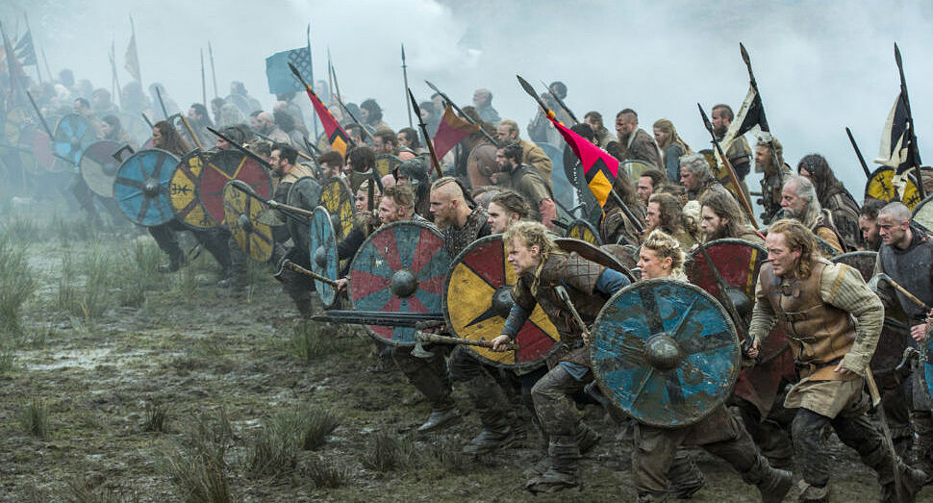

**Act II – Confrontation**

Our leader is now stuck in this fairy-like world, and her memories are all blurry. However, she finds this wizard that calls himself Volnax, who claims that he knows how to get the memories back. Volnax told her to find Holian Moss, which is in a deep slumber somewhere in this realm. She finds Holian, which casts a spell and gets her memories back. Now, she only needs to find a way out and get back to her clan. She learns about the existence of end stones, that can get people to the place they think of when touching them. Therefore, she starts her journey in finding these stones. She makes her way by jumping over huge rocks, avoiding traps, and using magical flying carpets. On her path, she meets other creatures that help her, but also creatures that try to kill her. After passing through all the obstacles she can finally see the end stone, which is not far. However, there is a familiar figure blocking the path. After getting closer she realizes the figure is the dwarf that got her down on the battlefield.

This part can be unraveled only by talking with the characters found throughout the game, which is optional, however there is a dialogue between the player and the final boss ( the dwarf) that explains some of the story in a general way, so that it doesn’t get the player bored.

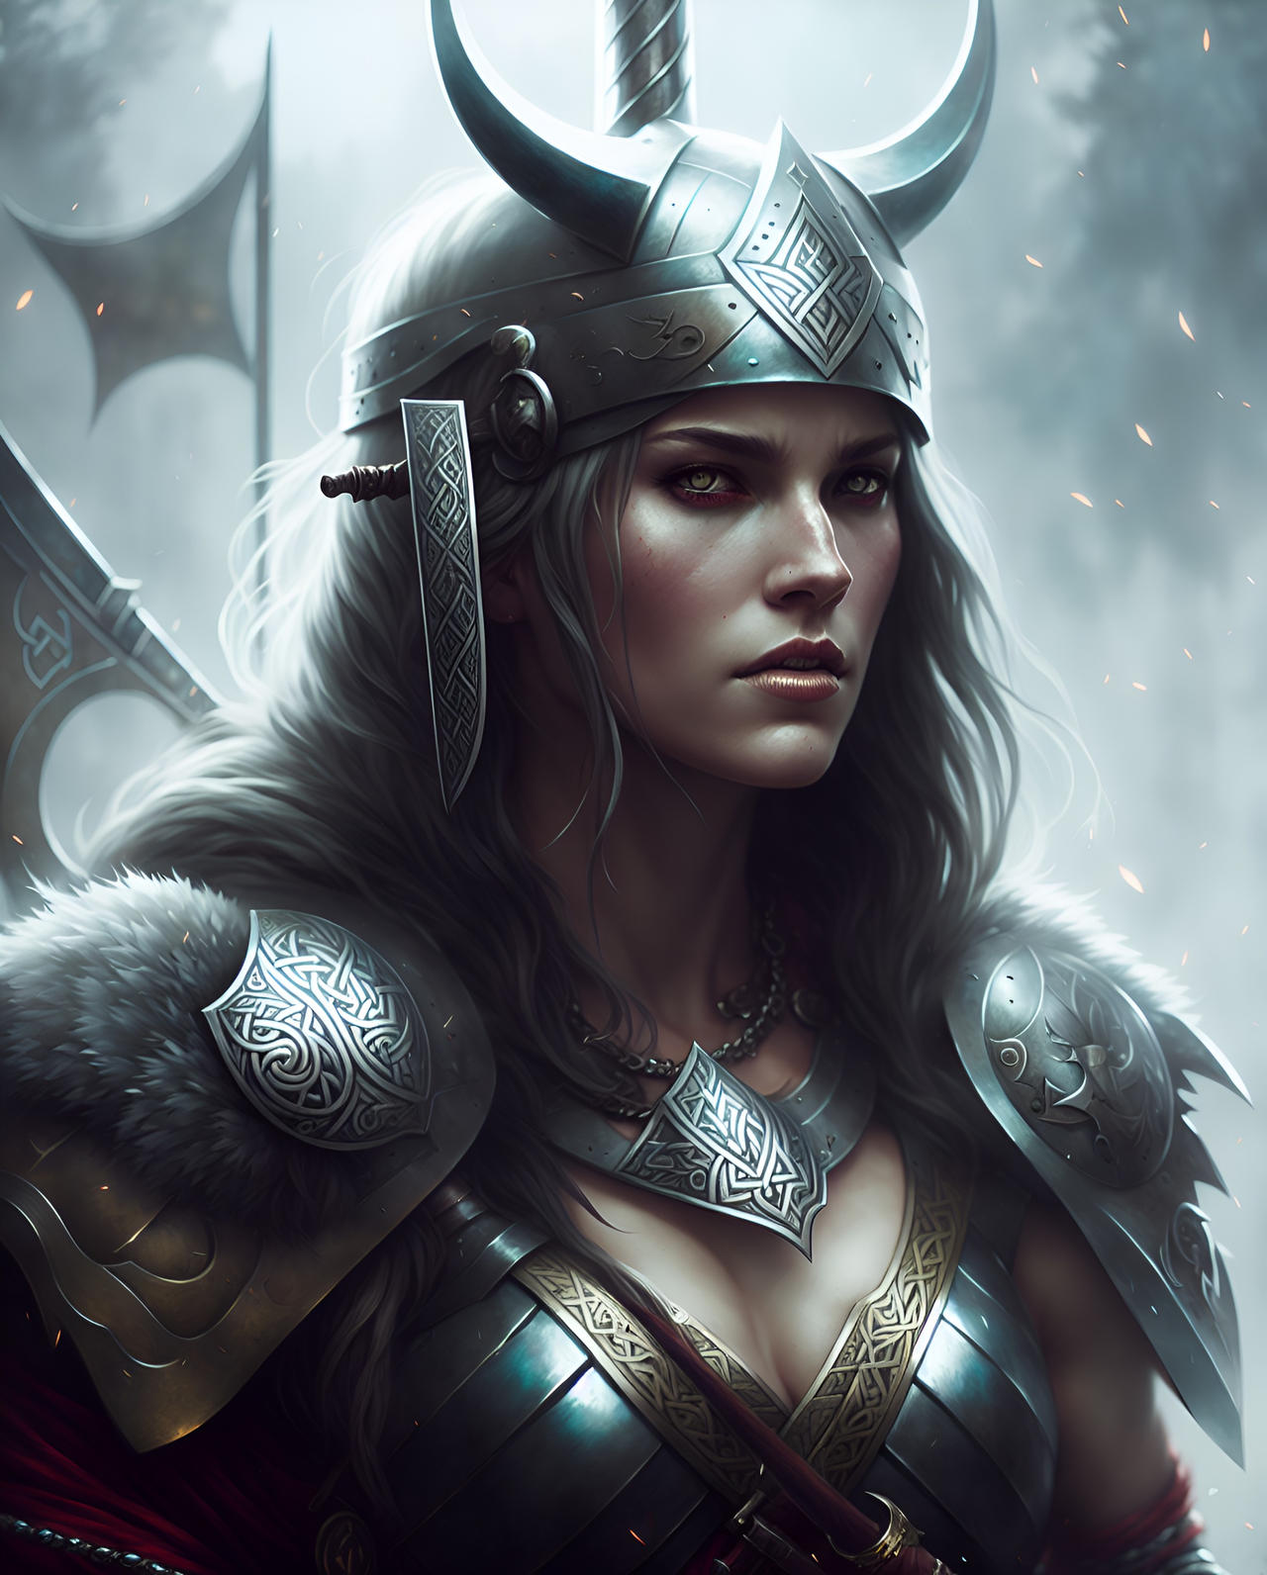

**Act III – Resolution**

Full of rage and hatred, Myru dashes to the dwarf, and they both start swinging their weapons. She realized the mistake she made when they were fighting in the battlefield, so she was able to dodge his crushing blow, then counterattack and kill the dwarf. Our clan leader is victorious, and she is now ready to go back on the battlefield. She touched the end stone, and started thinking about the battlefield, but nothing was happening. She kept trying and trying but to no avail. She felt betrayed, as she thought that all those creatures lied to her. That is when she started bursting into tears. It was during that time when the hourglass she found started making a loud resonating sound and it was shaking. Not knowing what to do, she threw the hourglass away. The glass broke, and in that moment, Myru was back on the battlefield, on the ground, right when she was supposed to get the final strike from the dwarf. She was so glad to be back, but there was still a battle to win. She used what she learned in her previous fight and was able to get up and kill the dwarf once again. Motivated and devoted, Myru rallied the clan with a battle shout, and was able to defend her home once again. Once the battle is finished, she realizes that the hourglass is still in her pocket, unaware of its true power.

Depending on the player actions they will be experiencing one of the two endings. The first ending is unlocked when the player collects all the artifacts, and that is when they get teleported after the boss fight. The second ending doesn’t teleport the player after the dwarf is killed, and they have to go through a few more levels to find another endstone.

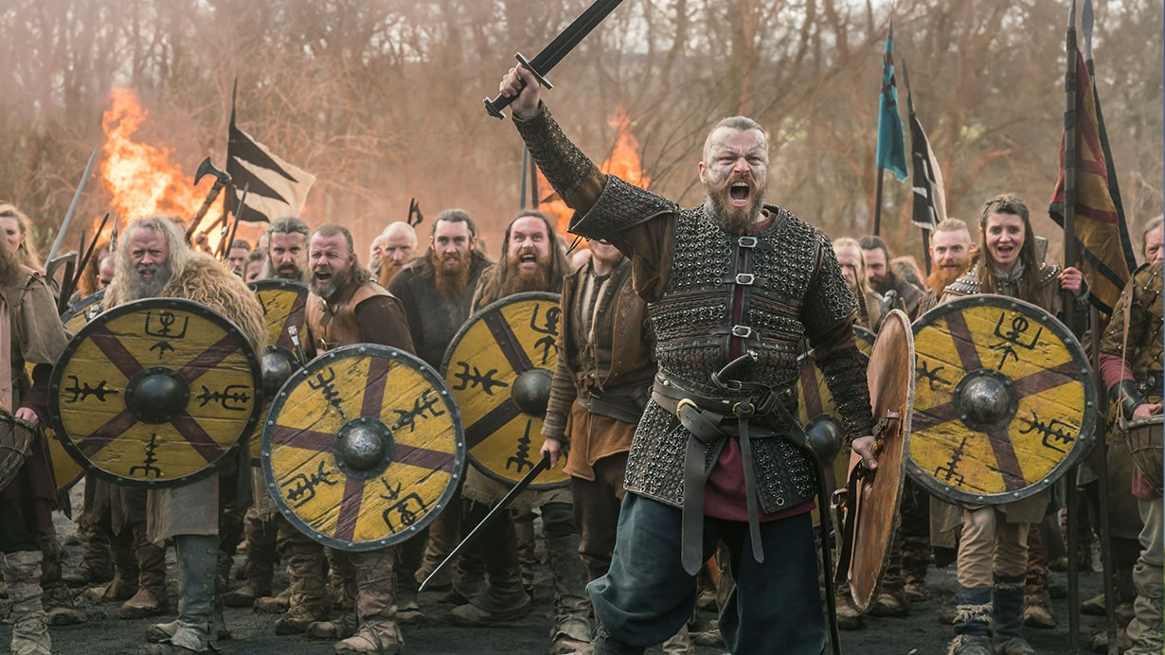

**Old Flowchart**

Flowcharts are essential when designing a game because they show the progression of level design and how the game is intended to be developed. In this flowchart you can see all the ways the player could interact with the game, including the settings and tutorial. However, I am now aware that this is quite vague, and it doesn’t include the new things that I have implemented in the game. This is the first flowchart that I have made for all the elements in the game, however it does not go much into detail when it comes to the level design, so I decided to make a new one.

**New Flowchart**

This is the new flowchart that I have made which is purely intended for the first level. My game concept follows a semi linear path, as there will be multiple endings in the final version of the game. The actions of the player will have consequences on their story, but that will only happen on specific events, such as the fight at the end of last level, and by collecting the artifacts. The player will be able to interact with the first level as shown in the flowchart.

**Annotated Map**

To get a better overview of the level design, I have divided the annotated map into two parts: the right side of the map and the left side. In regular platformer games, people tend to go on the right side, as that’s where the level usually ends. This is where they will find platforms and parkour with a level of difficulty that gradually increases. The players will progressively learn the mechanics of the game and get used to them.

During this time, they will realize that they are missing something, which is one of the three artifacts that can be found on the map. That artifact is located on the other side of the level. To get there, the player already needs to be familiar with the mechanics and some skill will be required to get to the artifact, which will discourage the player from going on the left side and exploring the right side. After they finish exploring and feel confident enough, they will return to the challenge, and have a feeling of accomplishment when they successfully do it. So, to reward the players that go out of their way to find the artifact on the left side of the map, they will unlock a different ending of the game.

**World Building**

To introduce the player to this immersive experience, I have carefully designed the environment, the characters, and the music so that the player feels engaged and connected to the game. However, I tried not to give directions to the player, such as which way to go, as sometimes it is better not to tell everything to the player and rather give them suggestions.

**Props**

There are different types of decorative objects such as road lamps, torches, flowers, trees, monuments, bushes, banners, bridges, chests, barrels, and signs which are carefully placed throughout the level.

**Rewards/ Collectible items**

Throughout the level, the player can find time orbs, that give additional time (5 seconds). These can be found in different parts of the level such as in between jumps, or that require an additional move from the player to be obtained. Moreover, there are multiple checkpoints in the level that can make progress less boring. Their main purpose is to fuel the gameplay and add to the flow of the level.

**Memorability**

Some jumps can be quite difficult, and might take a couple tries before succeeding, which is something the player will remember about the game. This might bring some frustration when thinking about the game, but it is something that they will remember.

The design of the level relates to the narrative backstory, the internal goals and gameplay goals, with the use of checkpoints, well-placed objects, and challenging parts, giving a more immersive experience.

**Challenges**

The game starts off with simple mechanics that everyone can learn, however obtaining the artifacts is the most challenging part of the game. It requires a coordination of patience, coordination, and timing. This part can make the players feel frustrated, but with trial and error, they will eventually obtain it, which will keep them hooked to collect the other artifacts and get to the end of the game.

**Tension curves**

The first tension curve represents the entire game, where the Setup, Confrontation, and Resolution represent one of the levels, which are connected to the beat chart.

The second tension curve focuses on the first level, where the main goal is to get to the end stone(ending), before the time runs out.

**Beat chart**

This beat chart shows the relevant moments and elements within the upcoming levels. There will be a total of 3 levels, in which different mechanics, enemies, and interactions will be gradually unlocked. The levels will be designed in a way so that the player has time to learn the new mechanic, get used to it, then give them complex ways of using it. Throughout the aesthetics the player will realize the change of seasons, going from summer to autumn to winter, empowering the feeling of time passing. Also, the beat chart communicates the game flow, tells the progress and the type of gameplay found in every level.

**Feedback loops**

Here is a list of the positive and negative feedback loops that can be found in the game.

**Positive Feedback Loops**

**-** While the player is progressing through the game, they will find checkpoints that reward their progress so far, by not having to re-do previous difficult parts of the level

-Making successful jumps rewards the player with time orbs,

- While players improve their skills (jumping, timing, precision), they are rewarded with progress

**-** Exploration and finding secret areas reward the player with shortcuts or artifacts

**Negative Feedback Loops**

**-** Falling off, or colliding with traps penalizes the player with loss of progress, as checkpoints are not that frequent

- Some segments of the level can be more difficult than others, so the player is punished for the lack of preparation

- If the player is not patient, falling off can occur more frequently

**Art Style and aesthetics**

**Environment**

The environment can greatly influence the player’s perspective and it can be used to guide the player throughout the game or to purposely make things confusing. To start envisioning the style that I will be using for my game, my first step was to find some references or concept art that I can use.

For the first level, I have chosen a summer forest to represent my environment. Forest environments are familiar and relatable to most of the players, and most importantly they do not harass the player with too much art, keeping them immersed into the game and avoiding resentment. The player can be one with the natural yet medieval environment, where they can see wooden buildings, which remind them of how simple things were in the past, and connect to the narrative story. This environment is great for the player to learn new things, in this relaxing, alive forest, which is one of the internal goals.

**Theme and Mood**

-The three levels of the game will represent 3 seasons, focusing on nature and medieval constructions

- Progressive change of seasons

-Fantasy

-Exploring the ancient land

**Form**

* Pixel adventure music
* Mystic forest
* Mysterious characters

**Style**

* Pixel art
* Environment and main character linked to the narrative setting.

**Setting**

The player is dropped from the sky on this small island, where they find one of the NPC’s, that gives them an optional quest. From this point, the player can either explore the left side or the right side, both sides have important elements, so players might consider exploring them both.

**Colors and Lightning**

Sometimes colors or lightning can be used as a way to guide the player throughout the level. Having a color that stands out or a powerful light usually attracts the player, can change their emotions.I included torches and street lamps to assure the player they are on the right path. The color pallette that I have chosen includes the main forest colors, but also blue and white which are used for the sky.

**Future development and peer feedback**

**Future Development**

In the future I would like to implement the other levels, all with new mechanics and elements so that the player can truly experience the game ( see “Beat chart”). Moreover, the NPC’s will have more interactions, and some of them will have quests in which the player has to bring them specific items to further progress through the level. There will also be hidden items and coins, which the player will be able to find by looking around through the level, some will be hidden in the ground, others will be in chests. There will also be a puzzle mechanic in which the player will need to find specific items in order to unlock doors and progress further through the level.

My next step would be to start working on the next levels, by having different assets and new mechanics that the player will be using in different circumstances. There will also be AI enemies that would just patrol around, or start following the player if they see them.

My final step would be to develop cutscenes( see “Back story”), so that the game will make more sense and the players would still understand their objective without having to talk with all NPC’s.

**Peer feedback**

I have made a list with the types of feedback that I received while developing the game and asking questions about the concept, level, design and mechanics:

Positive feedback:

* Game looks visually appealing
* The user interface is minimalistic
* The mechanics are easy to understand

Negative feedback:

* The collisions are not well made, and sometimes I fall even when I shouldn’t(iteration
* There is too much text when talking with the NPC’s(iteration

Adaptive feedback:

* Having collectible cherries is interesting, but changing their purpose should make the game more coherent
* The way of expressing the story is interesting, but being able to explain it through other ways rather than NPC’s should be more appealing to the player

Emotional feedback

* The narrative arc is well-taught, which really changes my perspective of characters, but consider giving more details about their personalities
* The environment is quite relaxing, but you should maybe implement more sound effects and music for a more immersive experience

**Playtesting**

I was able to get valuable insights by playtesting my first level and some of the potential mechanics that will be implemented in the game. Most of the mechanics of the game worked properly and there were no issues reported, except for a collision issue with the moving platform(see “Annotated Map”), where the player would sometimes get stuck on the corner or would fall through the map when jumping off of it.

**Game walkthrough**

Here is a video of the game walkthrough, in case some parts or mechanics were missed while testing the game: <https://www.youtube.com/watch?v=69bXsBLnyto>

**One pager**

**Sources**

**Assets**

Pixel Art Platformer - Village Props - <https://assetstore.unity.com/packages/2d/environments/pixel-art-platformer-village-props-166114>

Pixel Adventure 1 - <https://assetstore.unity.com/packages/2d/characters/pixel-adventure-1-155360>

Warrior free asset- <https://assetstore.unity.com/packages/2d/characters/warrior-free-asset-195707>

Forest Character Pack 2 - <https://pedrodis.itch.io/theforestcharacterpack2>

2D Pixel Art platformer biome plains <https://assetstore.unity.com/packages/2d/environments/2d-pixel-art-platformer-biome-plains-255002>

Casual Game BGM- <https://assetstore.unity.com/packages/audio/music/casual-game-bgm-5-135943>

Free Casual Relaxing Game Music Pack- <https://assetstore.unity.com/packages/audio/music/free-casual-relaxing-game-music-pack-262740>

8 Bit music 062022- <https://assetstore.unity.com/packages/audio/music/8bit-music-062022-225623>

Free winter backgrounds pixel art - <https://craftpix.net/freebies/free-winter-backgrounds-pixel-art/>

UI icons - <https://cazwolf.itch.io/caz-pixel-free>

**Images**

Viking images:

<https://www.history.co.uk/shows/vikings/5-fiercest-viking-warriors-from-harald-hardrada-to-ivar-the-boneless>

<https://www.deviantart.com/zamonelli/art/Viking-Woman-Warrior-950816787>

<https://www.outfit4events.com/eur/articles/weapons/vikings-arms/>

Environment images:

<https://www.freepik.com/premium-vector/8bit-pixel-autumn-forest-landscape-ai-generated-retro-pixel-art-game-background-ai-generative-arcade-location-level-featuring-pixelated-trees-falling-leaves-warm-colors-nostalgic-gaming-scene_60119696.htm>

<https://stock.adobe.com/nl/search/images?k=pixel+forest&asset_id=562564643>

<https://www.freepik.com/premium-vector/generative-ai-mountain-lake-landscape-8bit-pixel-art-background-arcade-game-scene-with-serene-ambiance-reflecting-sunlight-calm-water-pixelated-nostalgic-classic-videogame-parallax-level_60120595.htm>

Color palettes:

<https://www.color-hex.com/color-palette/7321>

<https://www.pastelcolorpalettes.com/pastel-forest-and-sky>

# **References**

2023, C. U. (2023). *Cambridge Dictionary*. Retrieved from Cambridge Dictionary: https://dictionary.cambridge.org/dictionary/english/odyssey

Brooks, N. (2021, February 23). *CBR*. Retrieved from CBR: https://www.cbr.com/platformers-important-gaming/

Clack, N. (2023, May 10). *Demographics of Player of Platformer Games (2D and 3D)*. Retrieved from gamedev: https://www.gamedev.net/blogs/entry/2276048-demographics-of-players-of-platformer-games-2d-and-3d/

Miro. (2023). *Miro*. Retrieved from Miro: https://miro.com/app/dashboard/

Wikiepdia. (2023, November 12). *Wikipedia*. Retrieved from Wikipedia: https://en.wikipedia.org/wiki/Platformer